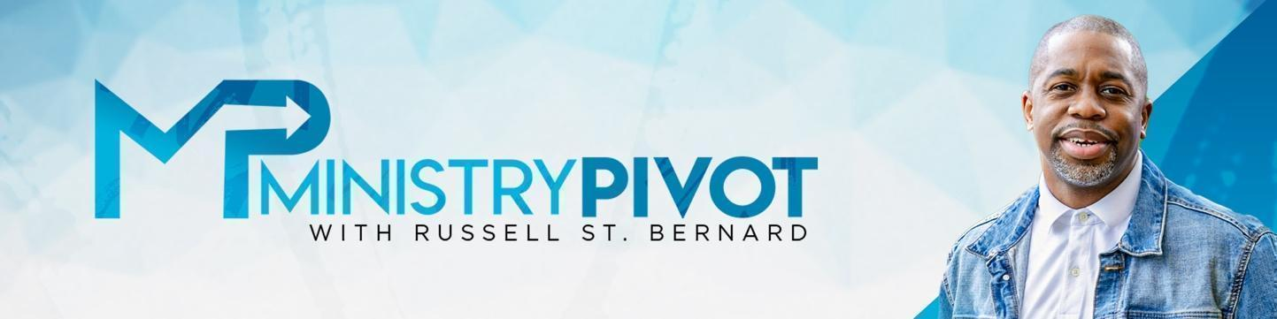

Culture Shifts Part 3: Identifying and Repairing Culture Leaks

Description:
In Part 3 of the Culture Shifts series, Rev. Russ explores how even the best cultures can suffer from leaks and cracks—especially during seasons of growth or transition. This episode teaches leaders how to recognize these issues early and offers practical steps to pivot and repair their culture before small issues become major setbacks.

Whether you're leading a church, business, nonprofit, or team, this episode gives you the tools to evaluate and fortify your culture with clarity, communication, and trust.

Takeaways:
- Growth creates stress on culture. As teams expand, so must your communication and trust systems.
- Culture leaks happen when systems loosen—usually due to unclear expectations, poor communication, or lack of structure.
- Culture cracks can form when trust is missing. Leaders must learn to delegate and empower others to lead, even if their approach is different.
- The sooner you identify a leak, the easier it is to fix. Waiting too long increases damage and recovery time.
- Evaluation matters. You can’t fix what you haven’t measured. Regular check-ins and honest feedback loops are essential.

Other Key Points Suggested by Rev. Russell St. Bernard
- You must pivot the culture when needed. Culture doesn’t stay healthy on autopilot.
- Whatever you celebrate, you strengthen. Continually reinforcing your culture’s wins sustains long-term success.

Resources
- 5 Minute Pivot and Other Podcast by Rev. Russell St.Bernard https://ministrypivot.com/conversations/
- Articles from Rev. Russell St. Bernard: https://ministrypivot.com/articles/
- Purchase your Tickets for the TKN Leadership Summit: https://tknleadership.com/tkn-leadership-summit-2024/

Final Takeaway:
- Co-champions are key. Your culture is only as strong as the leaders helping to uphold it alongside you.
- Micromanaging isn’t the answer. Clear systems, not control, protect your culture from deterioration.
- Revisit your AIM → ACT → ACKNOWLEDGE cycle regularly to keep your culture aligned with your mission.

Discussion Questions: (discuss with your team or reflect on your own?)
- Are there any warning signs of culture leaks or cracks within your organization or team?
- How well do you trust your team to execute without micromanagement? What systems support that trust?
- What is your current method for evaluating culture health—and how often are you using it?

Podcast Resources
- For more podcasts and articles, visit www.ministrypivot.com
- Read the articles: Click Here
- To watch the video of this conversation, Click Here
- To Subscribe to the YouTube channel, Click Here
- To Subscribe to the audio Podcast, Click Here

