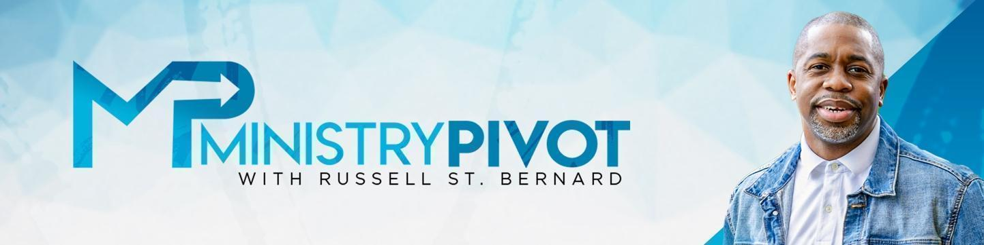

You Own the Building: An Engaging Talk with

Russell St. Bernard

### **Description:**

In this episode of the *Ministry Pivot* podcast, Rev. Russ discusses the empowering concept of 'owning the building.' Whether you're in church leadership, a business leader, or starting your own venture, Rev. Russ encourages you to break free from tradition, embrace new opportunities, and challenge your assumptions.

He shares insights from his leadership at Kingdom Fellowship and emphasizes the significance of seeing opportunities rather than restrictions. Don't miss out on leadership encouragement and details about the upcoming TKN Leadership Summit 2024.

### **Takeaways**:

* Embrace Ownership in Every Role: Whether you're leading a team, running a business, or managing personal goals, approach each role with the mindset that "you own the building." This perspective empowers you to make impactful changes and take initiative.
* Challenge Routine Assumptions: Don't feel bound by past patterns or methods. Break free from “the way things have always been done” to create fresh, innovative solutions that meet today’s needs.
* See Every Obstacle as an Opportunity: Instead of focusing on challenges, look for potential growth and new avenues in each situation. This shift can open doors and provide unexpected benefits.

### **Other Key Points Suggested by Rev. Russell St. Bernard**

* Take Calculated Risks: Sometimes, progress means going against the norm or even taking a financial hit to try new approaches. Trust your instincts and remember that trying new things can lead to surprising success.

### **Resources**

* 5 Minute Pivot and Other Podcast by Rev. Russell St.Bernard <https://ministrypivot.com/conversations/>
* Articles from Rev. Russell St. Bernard: <https://ministrypivot.com/articles/>
* Purchase your Tickets for the TKN Leadership Summit: <https://tknleadership.com/tkn-leadership-summit-2024/>

### **Final Takeaway:**

* Ask Yourself “What If?”: Cultivate a “what if” mentality to spark creativity and open the door to possibilities you may have otherwise dismissed. Consider the benefits of breaking out of comfort zones and trying new strategies.
* Let Purpose Drive Your Actions, Not Profit: Not every decision has to bring an immediate return. Sometimes, acting on purpose and passion—without worrying about immediate profit—yields the most fulfilling and long-lasting impact.

**Discussion Questions: (discuss with your team or reflect on your own?)**

* What areas of your work or personal life could benefit from adopting an "ownership" mindset, and how would this perspective change your approach?
* What are some assumptions or routines you currently follow that might be holding you back, and how could challenging these open new doors?
* How can we shift our focus from immediate rewards to actions driven by purpose and long-term impact?

# Podcast Resources

* For more podcasts and articles, visit [www.ministrypivot.com](http://www.ministrypivot.com/)
* Read the articles: [Click Here](https://ministrypivot.com/articles/)
* To watch the video of this conversation, [Click Here](https://ministrypivot.com/conversations/)
* To Subscribe to the YouTube channel, [Click Here](https://www.youtube.com/channel/UCCImzdEx-rB6WUiOlMYziSA)
* To Subscribe to the audio Podcast, [Click Here](https://podcasts.apple.com/us/podcast/ministry-pivot-with-russell-st-bernard/id1528485491)